RHEL/CentOS 7 (Red Hat Enterprise Linux) Installation steps

This article will explain you about the Installation of RHEL/CentOS 7. and It is mainly designed for modern data centers and cloud platforms and Big data.

[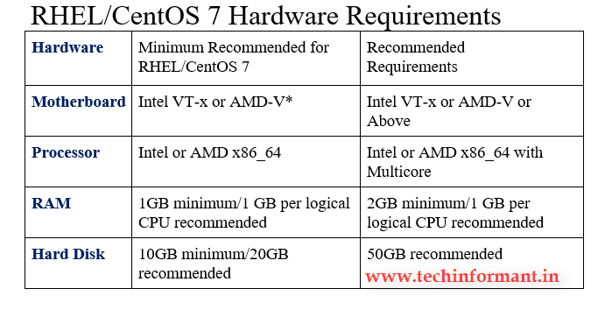](https://i0.wp.com/www.techinformant.in/wp-content/uploads/2016/10/RHEL-Reqirements.png)

**RHEL/CentOS 7 Feature and Capabilities**  
1. Supports only x86_64 architectures and supports Maximum 288 Logical CPUs  
2. Intel VT-x or AMD-V* and above  
3. Maximum Memory limit up to 12TB  
4. XFS Maximum File system size is 500TB  
5. Kernel version is 3.10  
6. Desktop GUI version is Gnome 3.8  
7. Graphics supporting X.org 7.7  
Note: These are the specifications provided by Red Hat. For more info visit: <https://access.redhat.com/articles/rhel-limits>

[[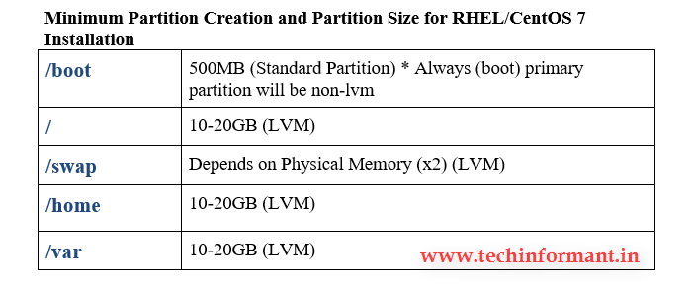](https://i0.wp.com/www.techinformant.in/wp-content/uploads/2016/10/requirements1.png)](https://i0.wp.com/www.techinformant.in/wp-content/uploads/2016/10/requirements1.png)

Before beginning the installation process, you must have to be download any of the RHEL/CentOS 7 DVD Binary ISO Image for installation  
**CentOS 7.x**  
Following URL link for Download the CentOS 7 DVD ISO image file:

[Download CentOS 7 ISO](http://isoredirect.centos.org/centos/7/isos/x86_64/)

**Step 1:**  
After the download of the latest version of Red Hat or CentOS DVD Binary ISO Image, burn the process in DVD or USB media.  
I’ll recommend you to use the open source tool to burn the DVD/USB. Click Here to download the tool – [Rufus](https://rufus.akeo.ie/downloads/rufus-2.11.exe)  
**Step 2:**  
After powering on the system, enter into BIOS settings and set DVD/USB drive as a first boot device, then make sure VT-x (Virtual Technology) is enabled then save the changes and restart the system to boot from DVD then select RHEL/CentOS 7 prompt and Install then Red Hat Enterprise Linux 7.x/CentOS 7.x[[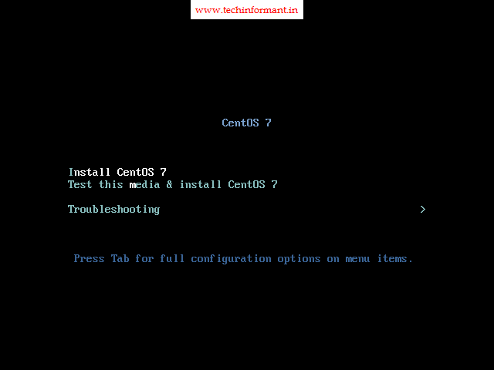](https://i0.wp.com/www.techinformant.in/wp-content/uploads/2016/10/1-2.png)](https://i0.wp.com/www.techinformant.in/wp-content/uploads/2016/10/1-2.png)

**Step 3:**  
After computer loads, the given details, select the **language** for the installation process and click on **continue**.[[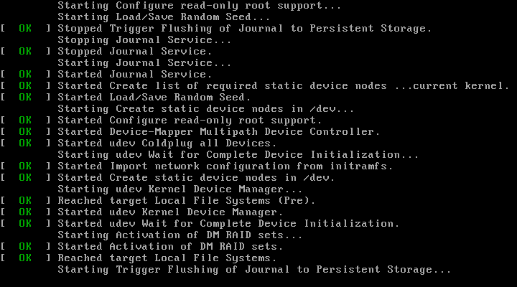](https://i0.wp.com/www.techinformant.in/wp-content/uploads/2016/10/Techinformant.png)](https://i0.wp.com/www.techinformant.in/wp-content/uploads/2016/10/Techinformant.png)

[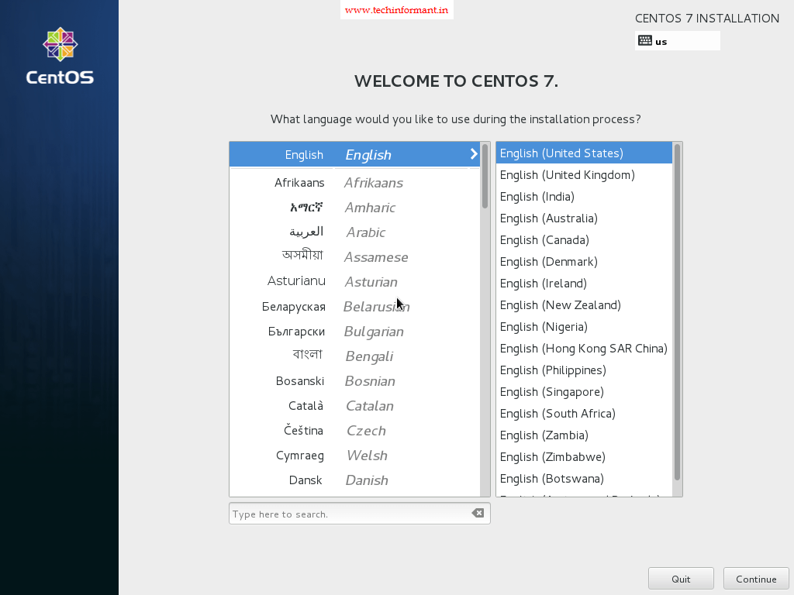](https://i0.wp.com/www.techinformant.in/wp-content/uploads/2016/10/3-2.png)

**Step 4:**

After the installation process clicks on **Date and Time**, choose your system location and click on done.

[[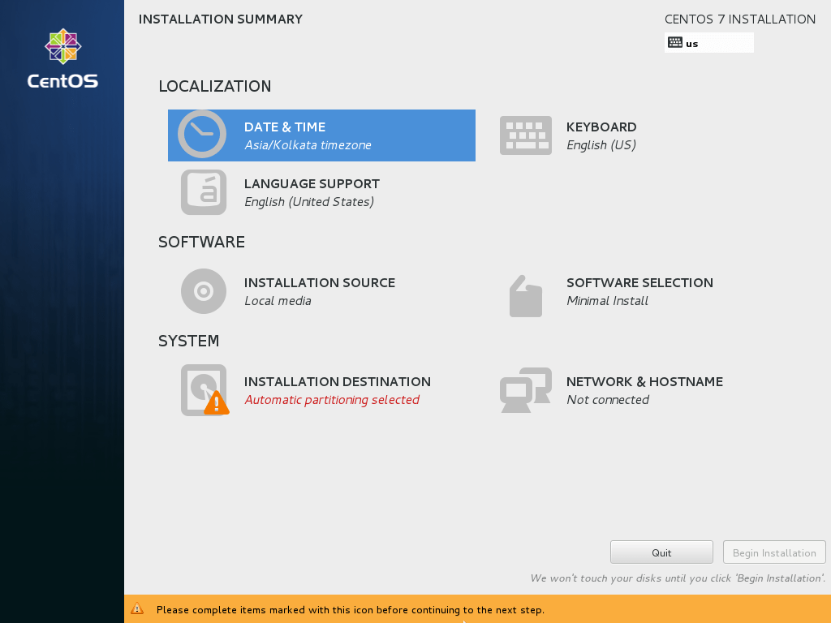](https://i0.wp.com/www.techinformant.in/wp-content/uploads/2016/10/VirtualBox_CentOS-7-New_13_10_2016_20_45_04.png)](https://i0.wp.com/www.techinformant.in/wp-content/uploads/2016/10/VirtualBox_CentOS-7-New_13_10_2016_20_45_04.png)

**Highlight date& time image below**

[[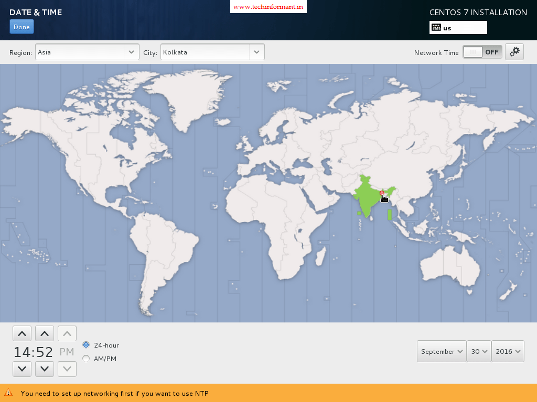](https://i0.wp.com/www.techinformant.in/wp-content/uploads/2016/10/4-1.png)](https://i0.wp.com/www.techinformant.in/wp-content/uploads/2016/10/4-1.png)

**Step 5:**  
In this step, we have so many options to change the Languages are language system support and Keyboard language. If you want to use both Languages click on both or you can add other languages but the server recommended language is English.[[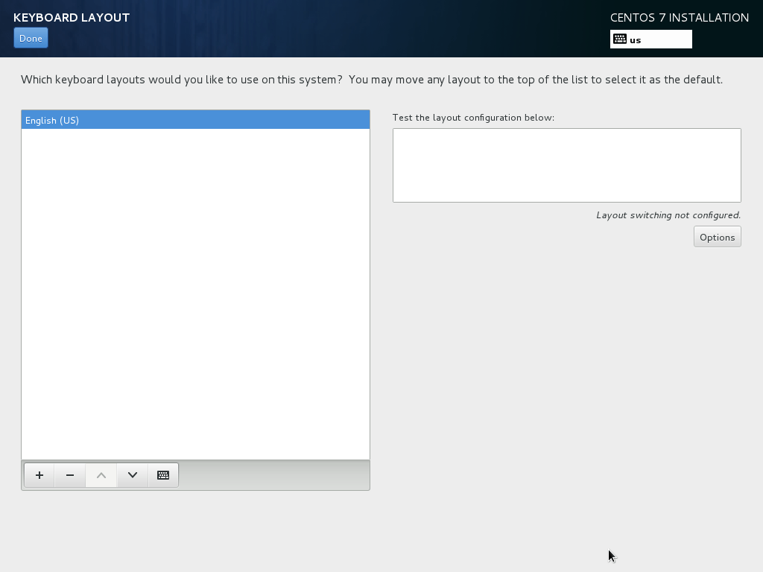](https://i0.wp.com/www.techinformant.in/wp-content/uploads/2016/10/keyboard.png)](https://i0.wp.com/www.techinformant.in/wp-content/uploads/2016/10/keyboard.png)   
**Step 6:**  
Other than DVD/Media sources If we want to use another one click on installation source and add your additional repositories or specify the network location using HTTP, HTTPS, FTP or any protocols then click on done. If there is no other sources then use by default option Auto detected Installation Media.  
**Highlight installation source image below**[[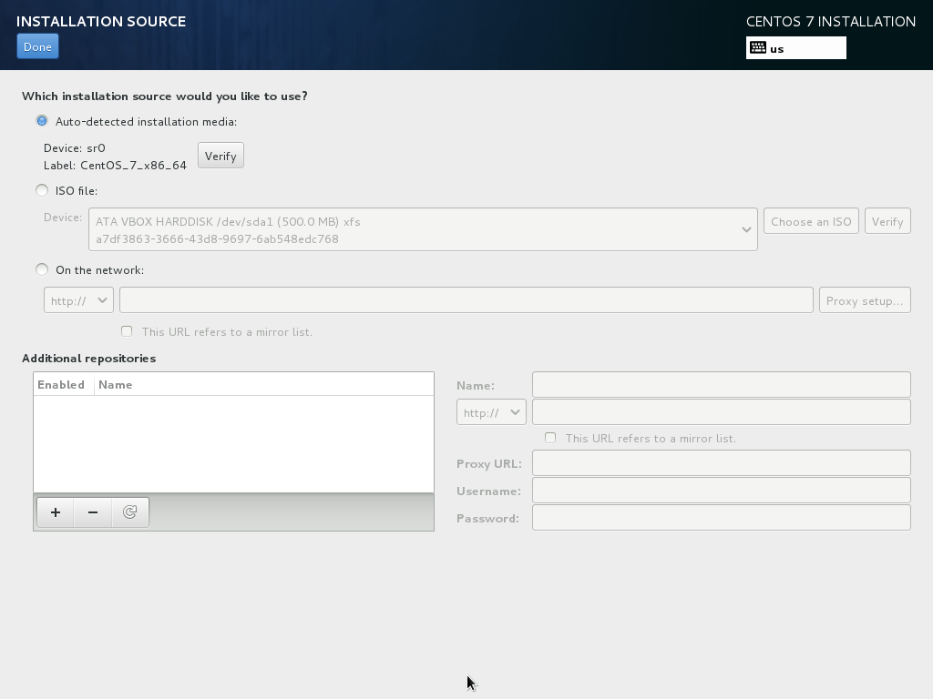](https://i0.wp.com/www.techinformant.in/wp-content/uploads/2016/10/VirtualBox_CentOS-7-New_13_10_2016_21_10_59.png)](https://i0.wp.com/www.techinformant.in/wp-content/uploads/2016/10/VirtualBox_CentOS-7-New_13_10_2016_21_10_59.png)

**Step 7:**  
After installation, source clicks on software selection and choose the base installation environment from the given n drop-down list. In this, you can install only the packages that we need after the installation. Then choose the **Server -Desktop or Minimal** Install with **Compatibility Add-ons,** then click on Done to apply the changes.[[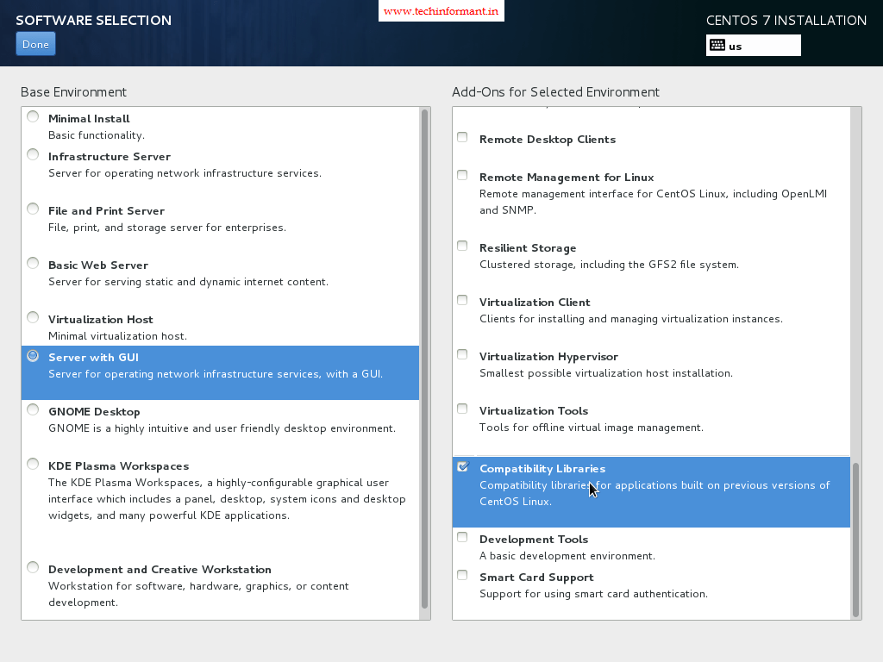](https://i0.wp.com/www.techinformant.in/wp-content/uploads/2016/10/5.png)](https://i0.wp.com/www.techinformant.in/wp-content/uploads/2016/10/5.png)

**Step 8:**  
Here the important step is to divide the partitions on your system. Click on Installation Destination and select the LVM as partition scheme for an (Optional) – better management, then Click the here option to create them automatically.  
**Highlight Installation Destination image below**

[**[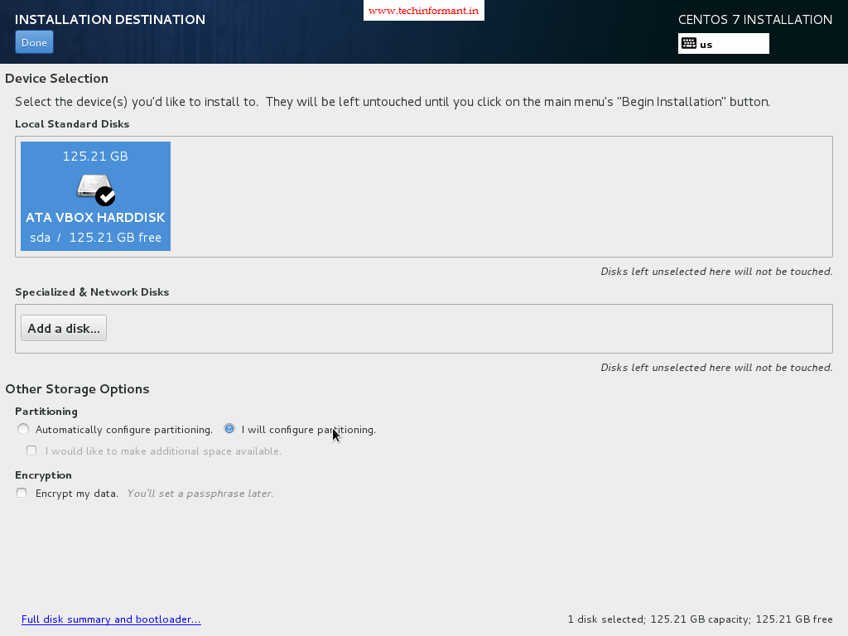](https://i0.wp.com/www.techinformant.in/wp-content/uploads/2016/10/6-3.png)**](https://i0.wp.com/www.techinformant.in/wp-content/uploads/2016/10/6-3.png) [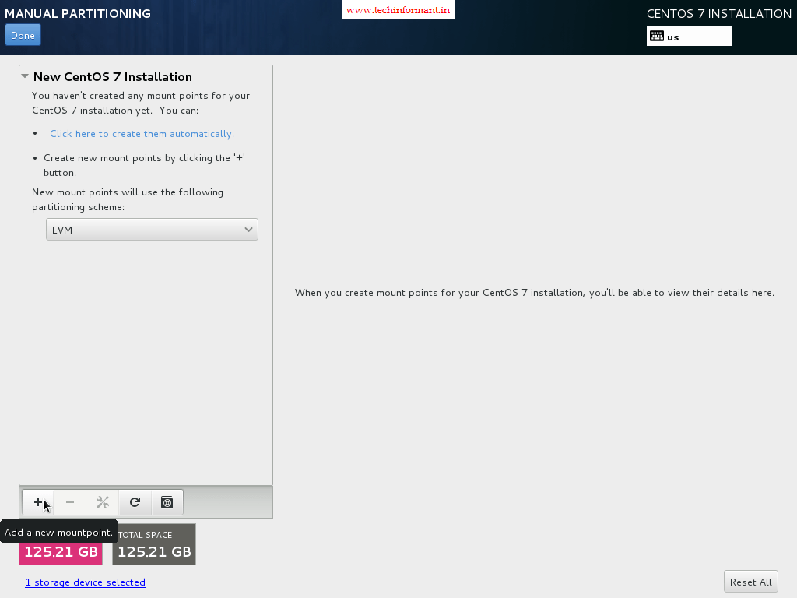](https://i0.wp.com/www.techinformant.in/wp-content/uploads/2016/10/7.png)

**Step 9:**  
After the default system partition, you can edit in many ways that suits to the system. In base scheme for a server you should use dedicated partitions such as:  
**/boot – 500 MB – non-LVM**  
**/ – min 20 GB – LVM**  
**/home – LVM**  
**/var – min 20 GB – LVM**  
After editing those partitions click on Update Setting button, then click on Done and then accept the changes that indicate you to apply for new configurations.

[[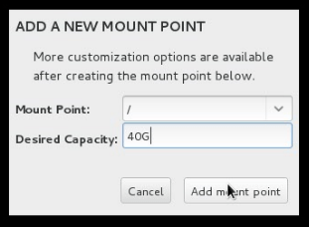](https://i0.wp.com/www.techinformant.in/wp-content/uploads/2016/10/partion.png)](https://i0.wp.com/www.techinformant.in/wp-content/uploads/2016/10/partion.png)

[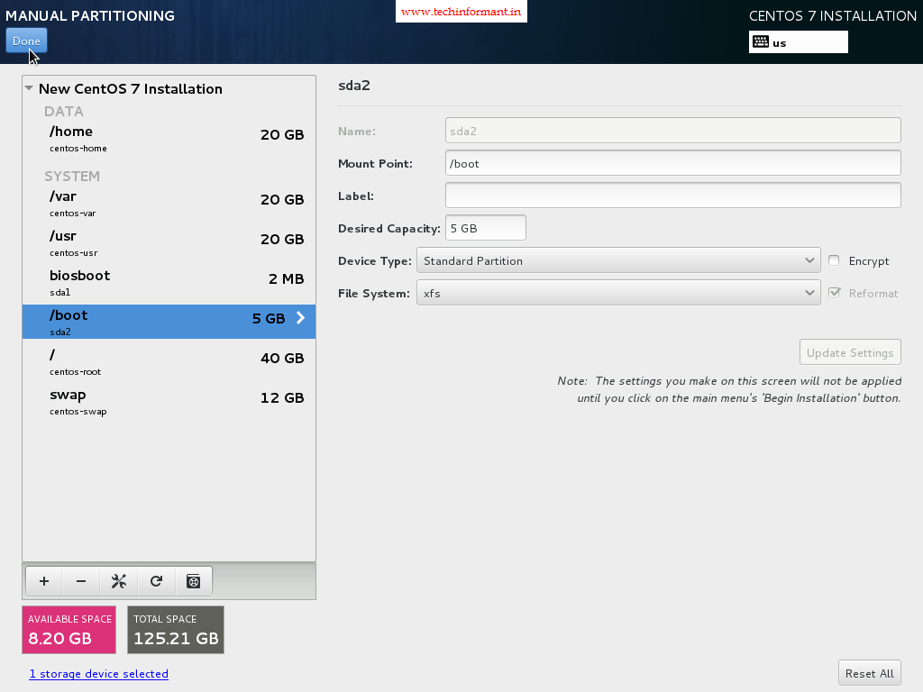](https://i0.wp.com/www.techinformant.in/wp-content/uploads/2016/10/9-1.png)[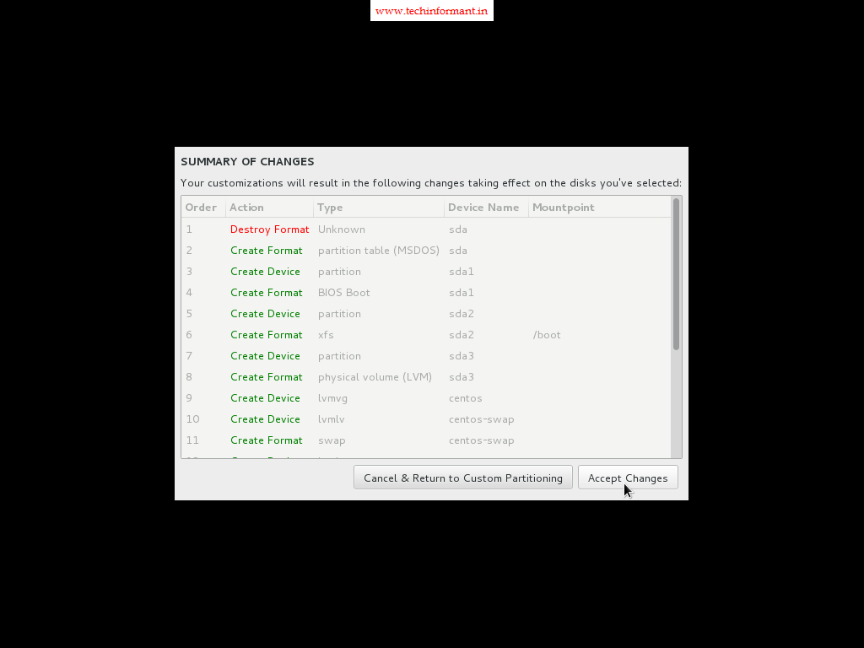](https://i0.wp.com/www.techinformant.in/wp-content/uploads/2016/10/10-1.png)

**Step10:**  
Before continuing with installation process set up your Network Connection. Then Click on **Network & Hostname** and setup your system hostname.[[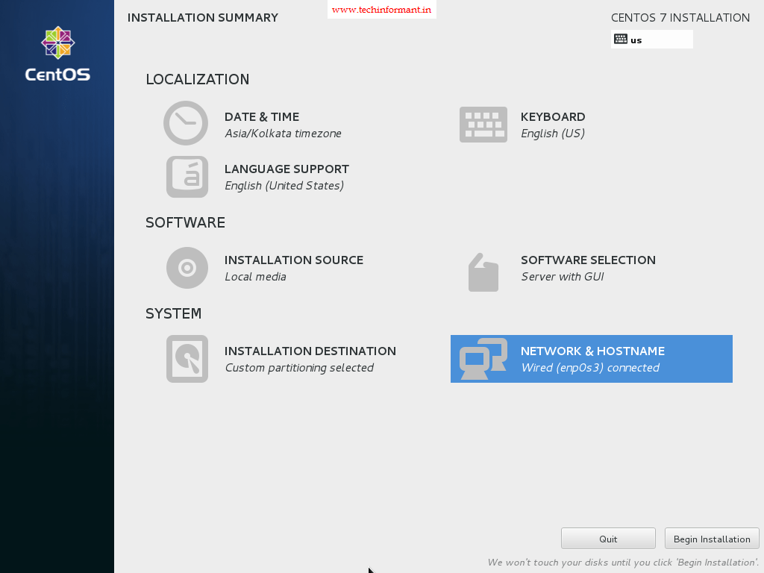](https://i0.wp.com/www.techinformant.in/wp-content/uploads/2016/10/12.png)](https://i0.wp.com/www.techinformant.in/wp-content/uploads/2016/10/12.png)

Continue to **Page 2**

**Step 11:**  
After the hostname setup the Network Interface by switching the top Ethernet button to ON. If your network provider provides the automatic Interface configurations through a DHCP server then your IPs should be visible on Ethernet Interface Card else go to Configure button and provide your static network settings for your appropriate network connection.[[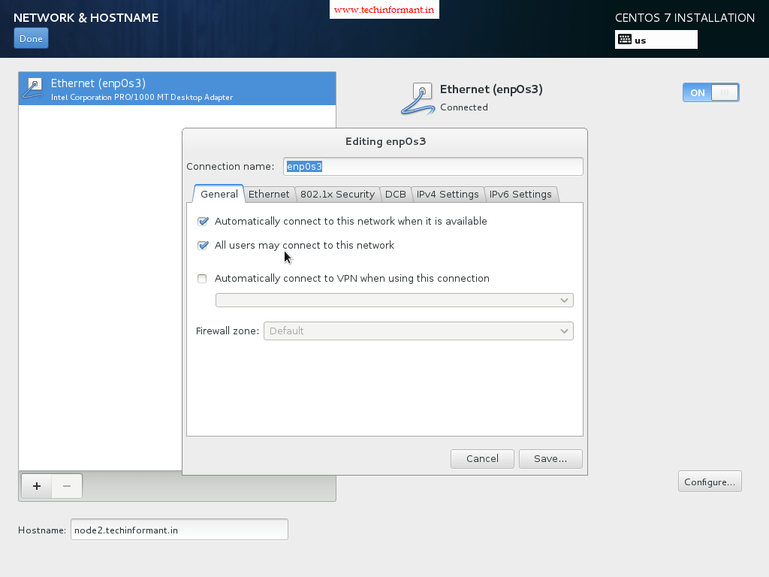](https://i0.wp.com/www.techinformant.in/wp-content/uploads/2016/10/11-1.png)](https://i0.wp.com/www.techinformant.in/wp-content/uploads/2016/10/11-1.png)   
**Step 12:**  
After the Ethernet Interface settings click on Done. It brings you to default window installer and after that check your installation settings click on Begin Installation to proceed further along with system installation.[[](https://i0.wp.com/www.techinformant.in/wp-content/uploads/2016/10/12.png)](https://i0.wp.com/www.techinformant.in/wp-content/uploads/2016/10/12.png)

**Step 13:**  
When the installation begins it writes the system components on your hard-disk, and then enter the Root Password and create a new User. Click on Root Password and choose a strong password with one at least eight characters in length (alpha-numerical and special characters) and click on Done.

[[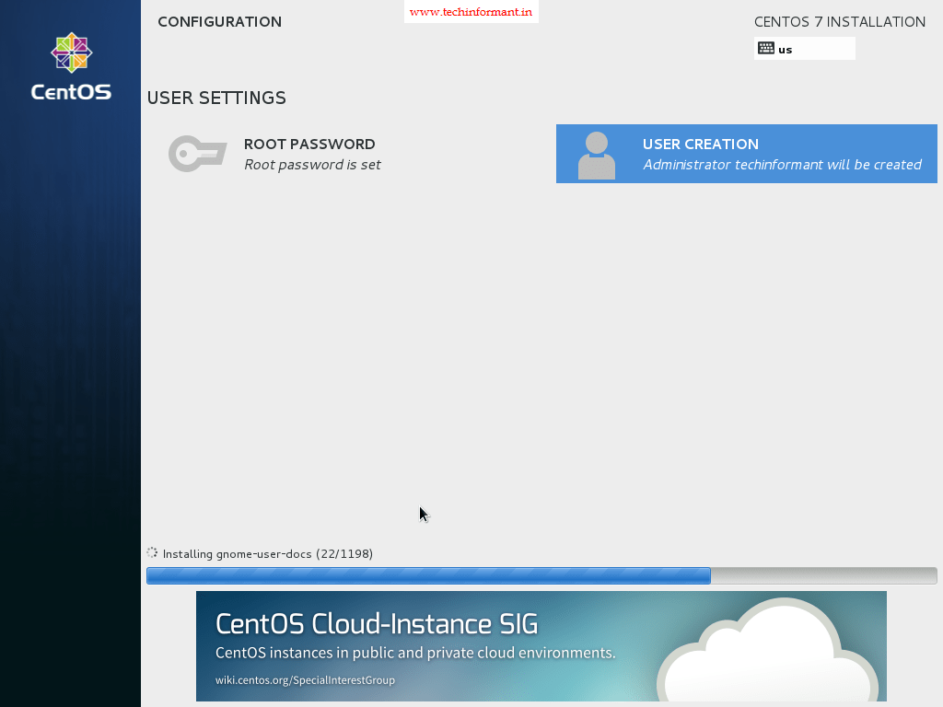](https://i0.wp.com/www.techinformant.in/wp-content/uploads/2016/10/15.png)](https://i0.wp.com/www.techinformant.in/wp-content/uploads/2016/10/15.png)[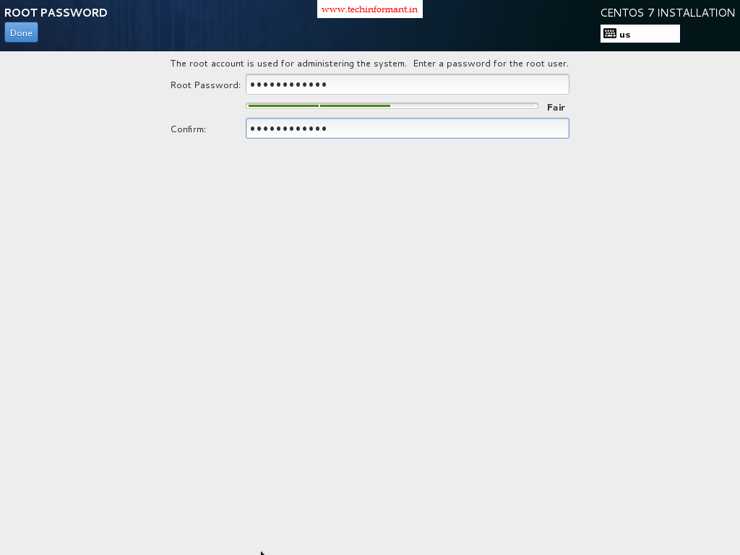](https://i0.wp.com/www.techinformant.in/wp-content/uploads/2016/10/13.png)

**Step 14:**  
After entering the root password then move to User Creation and provide your credentials for this new user, then click on Done and wait for the installation process to finish.

[](https://i0.wp.com/www.techinformant.in/wp-content/uploads/2016/10/15.png)

Creating local user and making him as a administrator ( Sudo persmissions)